Web Application Mockup / Design Specification
Screen 1: Dashboard / Home Screen
Overview: Main landing page after user login displaying high-level metrics and navigation.
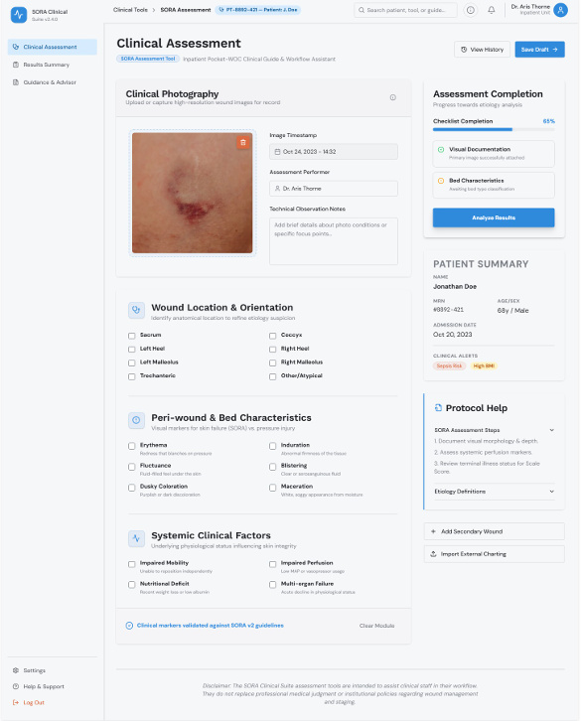

Screen 2: User Profile & Settings
Overview: Configuration screen allowing users to edit account details and preferences.
[ PASTE SCREEN 2 IMAGE HERE ]
(Tip: Right-click image > Format Picture to fine-tune height/width)
Key Features & Interactions:
- Editable user profile information form
- Tabbed sub-navigation (Security, Notifications, Billing)
- Save / Cancel action buttons at the bottom

Screen 3: Data Management / Table View
Overview: Interactive data list with filtering, sorting, and export functionality.
[ PASTE SCREEN 3 IMAGE HERE ]
(Tip: Right-click image > Format Picture to fine-tune height/width)
Key Features & Interactions:
- Search bar and multi-select filter dropdowns
- Paginated data table with sorting headers
- Export to CSV / PDF action buttons

